- Tên và phân loại:
Alias: Action, Transaction
- Mục đích, ý nghĩa:
Encapsulate a request as an object, thereby letting you
parameterize clients with different requests, queue or log
requests, and support undoable operations
- Động lực sử dụng:
Issue requests without knowing anything about the operation being requested or the receiver of the request
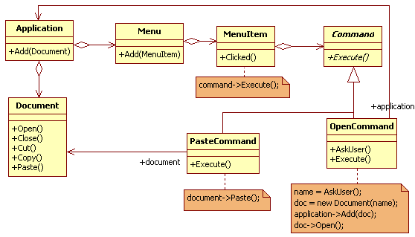
- Khi nào sử dụng:
- Parameterize objects by an action to perform
• You can express such parameterization in a procedural language with a
callback function, that is, a function that's registered somewhere to be
called at a later point
• Commands are an object-oriented replacement for callbacks

- Specify, queue, and execute requests at different times
• A Command object can have a lifetime independent of the original
request. If the receiver of a request can be represented in an address
space-independent way, then you can transfer a command object for the
request to a different process and fulfill the request there

- Support undo
• The Command's Execute operation can store state for reversing its effects
in the command itself
• The Command interface must have an added Unexecute operation that
reverses the effects of a previous call to Execute
• Executed commands are stored in a history list
• Unlimited-level undo and redo is achieved by traversing this list backwards
and forwards calling Unexecute and Execute, respectively

- Support logging changes so that they can be reapplied in
case of a system crash
• By augmenting the Command interface with load and store
operations, you can keep a persistent log of changes
• Recovering from a crash involves reloading logged commands
from disk and re-executing them with the Execute operation
- Cấu trúc
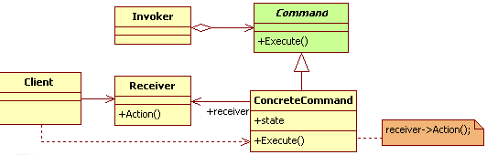
- Các thành viên - Sự cộng tác
- Command: declares an interface for executing an operation
- ConcreteCommand
• Defines a binding between a Receiver object and an action
• Implements Execute by invoking the corresponding operation(s) on
Receiver
- Client: creates a ConcreteCommand object and sets its receiver
- Invoker: asks the command to carry out the request
- Receiver
• Knows how to perform the operations associated with carrying out a
request
• Any class may serve as a Receiver
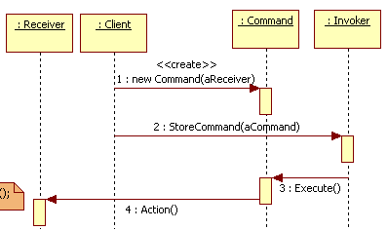
- Các hệ quả mang lại:
- Decouples the object that invokes the operation from the one
that knows how to perform it
- Are first-class objects. They can be manipulated and
extended like any other object
- You can assemble commands into a composite command.
- It's easy to add new Commands, because you don't have to
change existing classes
- Chú ý liên quan đến cài đặt:

- Hệ thống thực tế

- Mẫu liên quan
- A Composite can be used to implement Commands
- A Memento can keep state the command requires to undo its
effect
- A command that must be copied before being placed on the
history list acts as a Prototype

